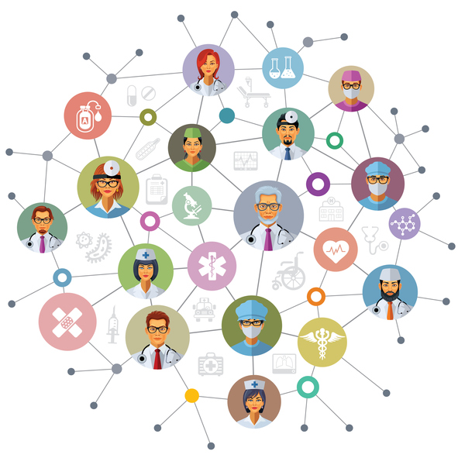

Using Social Media to Network Promote & Exchange
Scientific Ideas.

The Role of Social Media In Science Communication
Rates of social media use in the scientific community are low when compared to the general public or even to other professional groups. The traditional nature of scientific communication is unidirectional (think about conferences or articles in peer-reviewed journals), but this long-form narrative contrasts with the current evolution of communicative preferences across the globe.

Scientists and researchers usually prefer to use professional networks with a clear scientific or academic focus. This is the case of Researchgate, Academia, or Mendeley, which are considered the best scientific social networks. But this begs the question of whether platforms like Facebook, Twitter, or LinkedIn are being unfairly overlooked and could in fact contribute something to scientific research.

Within the scientific community, social media networks are generally perceived as not suited for “high-quality” science given the amount of banal or irrelevant content that is available on them. Credibility issues stem from the fact that very few authoritative voices are present on these platforms, but at the same time, this can be an opportunity for scientists to fill the void and help fight misinformation.

Social media networks can help spread scientific knowledge. Sharing is the very nature of these platforms, so they can help bring down barriers to the dissemination of scientific information and foster a culture of science communication between different stakeholders.

Social media also help make research and scientific contributions more widely available. Social media can contribute to the democratization of scientific discourse and make it available to more people.

Science itself can have a stronger online profile thanks to social networks. This can add credibility to the wealth of information generated in the public sphere, counter the effects of fake news or unproven claims with solid scientific research, and generate public debate about issues that are of paramount importance for society as a whole.

Advantages of Using Social Media for Science
The “Big 3” (Facebook, Twitter, and LinkedIn) have the potential to be the best scientific social networks if they are used to promote research interests expertly.

Pew Research showed that some science-related pages and Facebook profiles have a follower base in the tens of millions, there is potential for scientists to see this platform as a space where to create online communities that have common interests. The Pew study also showed that posts related to research funding achieved the highest engagement, and a University of Michigan study confirmed that many scientists think that having a social media presence can help them demonstrate relevance to funding agencies.

The digital revolution has provided alternative routes to disseminating scientific discoveries and keeping up-to-date with the literature. This is underscored by the emergence of ‘altmetrics’, article metrics that measure an article’s online exposure in the more traditional reference managers, but also news outlets and social media platforms. Although altmetric scores can provide useful information about the online attention garnered by a particular paper, it is important to remember that this is not a reflection of research quality or significance. Rather, altmetrics can provide routes for researchers to access media coverage and join the online conversation about specific papers.
LinkedIn
LinkedIn has a wider acceptance among scientists perhaps due to the idea that this network as a high-profile platform with a predominantly professional focus. But this platform offers more than the option to create an online profile, and it can become the virtual equivalent of a lab meeting or a discussion between like-minded professionals.

Twitter
If Twitter were a place… it would be a giant coffee lounge full of science enthusiasts just like you. Used properly, a Twitter network can broaden/change/improve your scientific thinking. The main reason scientists use Twitter is to follow discussions, and post work related content
Twitter is often used to interact with fellow scientists, tweet about research or link to relevant articles. Some studies have shown that academic tweets lead to increased citations and paper downloads, so this platform can be an alternative way of establishing a presence within the scientific community.
There are two Twitter features that are specifically useful in the scientific arena: conference hashtags have proven particularly powerful, and lists can help create online communities of individuals with common interests and goals. The constant stream of posts can be filtered to match the user’s interests through the creation of lists. Thus, researchers can group and follow specific accounts, for example journals, funders, institutes, science news outlets, bloggers and individual scientists, in separate threads.
Twitter also offers the possibility of communicating with a wide audience in real-time. The brevity of ‘tweets’, and the capacity to include images and videos, means that scientists can go through a lot of information at a glance, with the option to dig deeper if they wish.
Twitter can be used to support the scientific process by providing raw data that has immense value in and of itself from a sociological point of view. Researchers, scientists, and conference organizers can gain extremely valuable insights into how social media users react and interact with news and announcements, and these findings can be then used to discern patterns and modify online strategies to reach an even wider audience in terms that make sense to them.
Live-tweeting from conferences has become common and offers many benefits, such as allowing attendees and non-attendees alike to receive messages, as well as increasing interaction between conference attendees.
Academia.edu and ResearchGate cater to specific audiences, as they aim to foster academic and researcher interactions by building contact networks and facilitating communication between users. Either can also be used effectively to collaborate with other researchers on a common interest area.
Mendeley: Also caters to the academic sector, the platform can also help you grow your network by joining groups of your interest. You can view your research impact and view other popular works. Which sets it apart from Academia.edu and Researchgate. It is a subsidiary of Elsevier.
Medium: Is a website dedicated to promoting research. The longer the pieces ( 6-10 minute read) the more dedicated the reader. You can create your own community and have online dialogues, an advantage for research that is yet to be established in the academic community. It is also used as a platform to promote research and posters post-conference to disseminate new research to a wider audience.
All these social media channels need to create a profile and it requires a dedicated person to update the profile or page regularly with the latest in research and activities of the Center.
Solution – start with one or two
- Twitter for the your center
- Academai.edu for the professors
Tips for Twitter
- Get a hashtag for
  - The Center
  - The area of research
- Post pic with a link to the research
- to be engaging,
- retweet content that you’re tagged in
- retweet content of your peers/counterparts to increase your following
- Post an interesting result from the research
- Post results specific to designated health days
- Post with hashtag of an institution or person you want to expose your work to eg March of Dimes ( @MarchofDimes) so they can see it on their feed.
- Tip :Follow lots of people, especially those with similar interests as you. pick one person on Twitter, maybe someone you know in person or a scientist whose work you admire. Raid their following list for people to add to yours. Organize these people in Twitter lists so that the number of people you follow isn’t overwhelming. Also, find hashtags relevant to your field and monitor them regularly to stay up to date.
Wired has a useful tool on how to create and maintain a twitter account and the important role hashtags play here https://www.wired.com/story/how-to-setup-twitter-search-hashtag-and-login-help/

https://www.pewresearch.org/science/2018/03/21/user-engagement-with-posts-on-science-related-facebook-pages-is-more-common-for-visual-posts-calls-to-action/
http://graham.umich.edu/media/files/PrelimSurveyResults-PublicEngagement.pdf
https://www.linkedin.com
https://twitter.com
https://www.nature.com/news/online-collaboration-scientists-and-the-social-network-1.15711#/
https://www.academia.edu/
https://www.researchgate.net/
https://www.mendeley.com/?interaction_required=true
https://medium.com
https://help.twitter.com/en/using-twitter/twitter-lists

